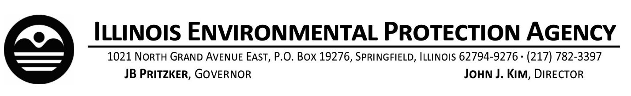
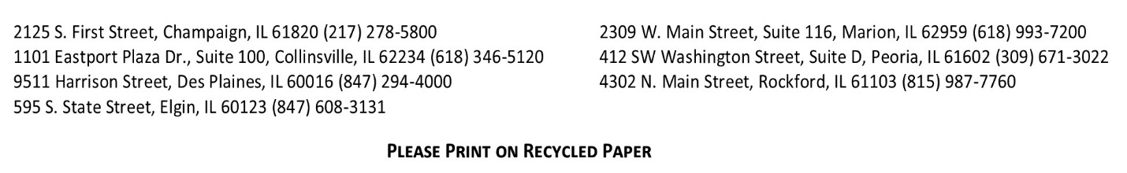
2024 Final Material Inventory: Extension Request
In accordance with Section 17.12 of the Illinois Environmental Protection Act, all community water supplies (CWS) must submit a final material inventory and initial service line replacement plan to the Illinois Environmental Protection Agency (Illinois EPA) by April 15, 2024. Extension requests are due to the IEPA by January 15, 2024.
In accordance with Section 17.12 of the Act, CWS may request an extension for the submittal of the final material inventory and initial lead service line replacement plan. All extension requests must be submitted to the Illinois EPA by email to: EPA.LeadandCopper@illinois.gov or by mail to: Illinois EPA, BOW/CAS #19, P.O. Box 19276, Springfield Illinois 62794-9276 by January 15th 2024.
Water System Name: _____________________________ Water System ID: IL _________
Water system representative requesting extension: ____________________________________
Phone number: _____________________ Signature: ____________________________________

Required information:
- Total number of service connections: _________
- Current number of known “lead” service lines: _________
- Current number of known “Non-Lead” Service lines: _________
- Current number of service lines yet to be identified (unknown): _________
- Additional time requested to complete final inventory: ________________
Additional information requested to process extension request:
What is the rationale for the requested extension timeframe?

Has your CWS requested funding under any of the Illinois EPA’s Notice of Funding Opportunities listed below?
Round 1 – posted 10/18/2022 Round 2 – posted 3/3/2023 Round 3 – posted 8/27/2023.

Has your CWS pursued or plan to pursue technical assistance from any organization to assist with completing the material inventory and lead service line replacement plan?

Will the inventory be completed by the CWS or an outside contractor?

Contact EPA.LeadandCopper@illinois.gov with any questions. Additional Illinois EPA lead service line information can be found at: https://epa.illinois.gov/topics/drinking-water/public-water-users/lead-service-line-information.html
Illinois EPA Lead Service Line Inventory Grant Program information can be found at:https://epa.illinois.gov/topics/drinking-water/public-water-users/lsli-grant-opportunity.html

